**Path Finding Algorithm Visualizer**

Introduction:

This is a simple web-based application created by Meghaj Singh and Pranay Mishra while working under the Microsoft Mars Colonization Program and in process developing our own path-finding algorithm visualizer.

To view the application, click here : <https://pranaymishra86.github.io/PFA/>

Tech – Stack:

For the Web app, we have used the following :

* HTML5
* CSS
* JavaScript

For the Backend of the Web app, we have used to algorithms :

* Breadth First Search
* Dijkstra’s Algorithm

Apart from these algorithms, we have used 2 main data structure:

* Queue
* Min Heap

Usage:

The application can be used by following these steps:

1. Set initial and target positions of the Mars Rover.
2. Add obstacles by clicking certain cells.
3. Set the speed of animation by selecting speed in the navigation bar.
4. Select the Algorithm of your choice and Press Start.

After this, the app will search for the shortest possible path between the initial and the target position keeping in view the obstacles and avoiding them. The green box on the right will display the time taken and the length of the shortest path from the source to the destination.

In order to re-run the app, you can press Clear button and follow the above steps once again.

By clicking on the Website info tab, you can view the details and the background of the project.

Further Improvements:

We plan to further add some more algorithms like A* search, Jump First Search algorithms etc.

Screenshots:

1. Home screen

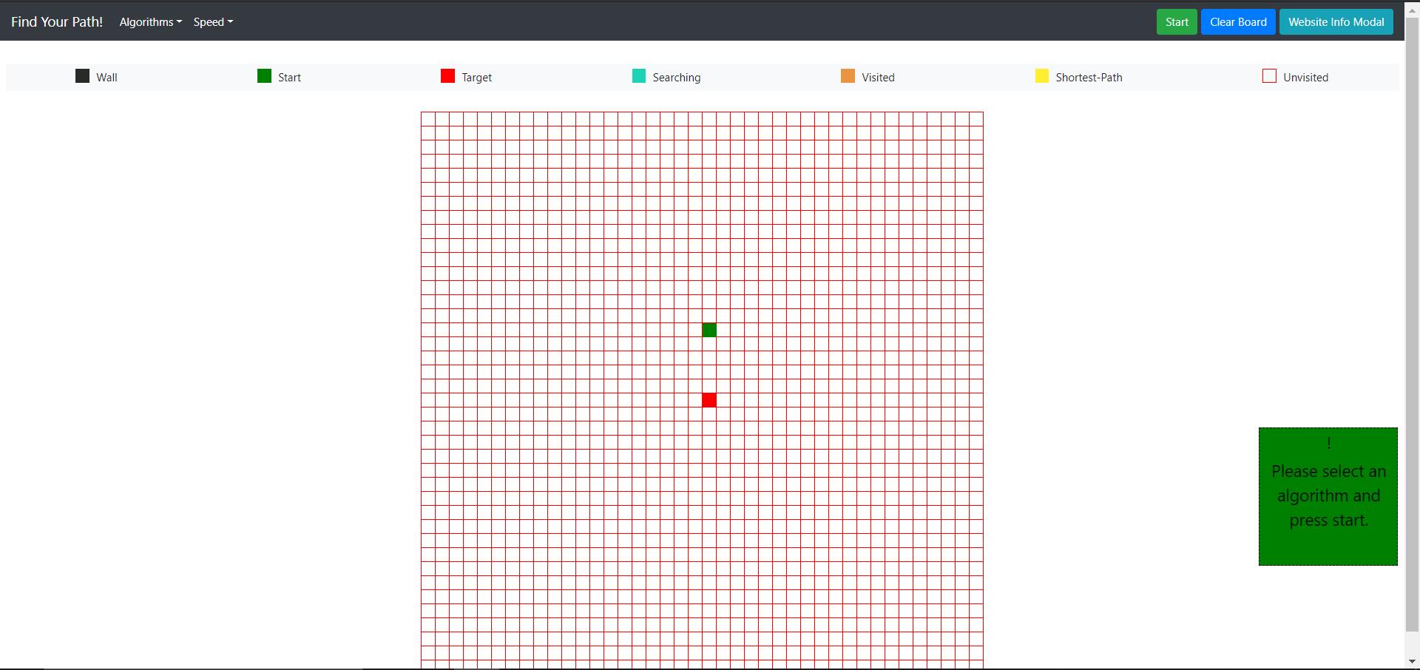

1. Selecting Algorithm



1. Selecting Speed

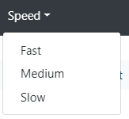

1. Adding Obstacles

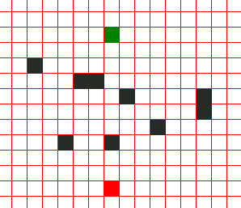

1. Shortest Path

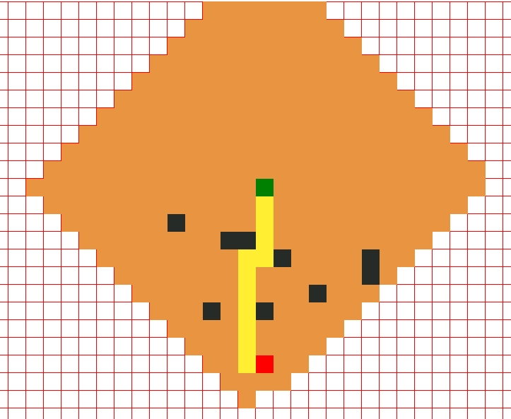

1. Details of the path

